INDIA OFFERS 55 DISCOVERED SMALL OIL GAS FIELDS (DSF Round IV)
- Discovered Small Fields auction is one of the distinct opportunities that suits both new entrepreneurs and existing companies in E&P Sector.
- Oil and Gas already discovered in these fields by ONGC, Oil India and other oil companies and hence carry low risk. These fields are now offered through bidding.
- No reimbursement of the existing assets or past cost incurred over the fields are to be made by the winners.
- Auction of Discovered Oil Gas Fields is one of the Government policy initiatives in E&P initiated in 2016. In the previous three auction rounds, 86 clusters/ areas were awarded. Some Fields are now producing oil/gas.
Find everything you want to know about the DSF Rounds at www.mytrustworthyadvisors. com or contact kumar@mytrustworthyadvisors.com

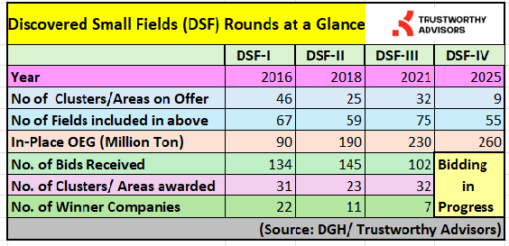
Who can Bid? Any company or consortium having a minimum net worth of $1 million (or a bank guarantee in lieu of that if the net worth requirement not meeting). No prior experience in oil sector required.
The Technical information about the fields are available from DGH.
But it is advisable the entrepreneurs/ investors in their own interest must do the due diligence of the fields before moving ahead.
Find everything you want to know about the DSF Rounds
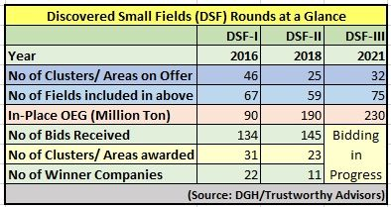

Auction of Discovered Oil Gas Fields is one of the Goverment policy initiatives in E&P initiated recently.
2. In the last two auction rounds, 54 clusters of fields were awarded. But the progress in the fields remained slow partly due to the delays in getting multiple statutory clearances, fund mobilisation and the outbreak of pandemic. However, some fields have just started producing. Some more expected in the current year.
3. In the present round, 75 fields clubbed into 32 contract areas having an estimated resource base of 1.7 billion barrels oil & oil equivalent gas are on offer.
4. The DSFs provide opportunities and challenges both for the Government and the Entrepreneurs to commence oil production within the stipulated timeline.

INDIA ANNOUNCES MAJOR CHANGES IN OIL GAS FIELDS OFFER TERMS
1. The Government has put 75 Discovered Small Oil Gas Fields. These fields together have 230 Million Tonnes of OEG Inplace.
2. The Government has recently announced major changes in the bidding terms- committed work programme and the Government share in Revenue.
3. The maximum limit of Government share in revenue is reduced to 50%. Higher weightage has been given to committed work program. PBG has been reduced to one-fourth for committed work program.
4. DSF offer has come up under the new policies with very liberal terms such as freedom to explore and produce any form of hydrocarbon including oil, gas, shale oil, shale gas & CBM, pricing & marketing freedom, reduced royalty and 100% participation by the foreign companies.
5. Oil and Gas already discovered in these fields by ONGC, Oil India and other oil companies and hence carry low risk. Moreover, no signature bonus or reimbursement of past cost or the existing assets in the field to be made.
6. In earlier bidding rounds, 30 clusters of oilfields in DSF-I and 23 clusters in DSF-II were awarded.
7. The current bidding round is a win-win situation both for Government and the Entrepreneurs.
hashtag#oilandgas hashtag#petroleum hashtag#dghindia hashtag#mopng hashtag#nitiayog hashtag#ongc hashtag#oilindia hashtag#cairn hashtag#vedanta hashtag#ioc hashtag#hoec hashtag#reliance hashtag#bp hashtag#gail hashtag#bprl hashtag#trustworthyadvisors hashtag#sunpetrochemicals hashtag#oilfieldservices hashtag#schlumberger hashtag#haliburton hashtag#bakerhughes hashtag#bjservices hashtag#petronas hashtag#total hashtag#exxonmobil hashtag#eni hashtag#dgh hashtag#oil hashtag#gas hashtag#naturalgas hashtag#oilexploration hashtag#india hashtag#oilandgasindustry hashtag#oilindustry hashtag#cbm hashtag#dsf hashtag#india

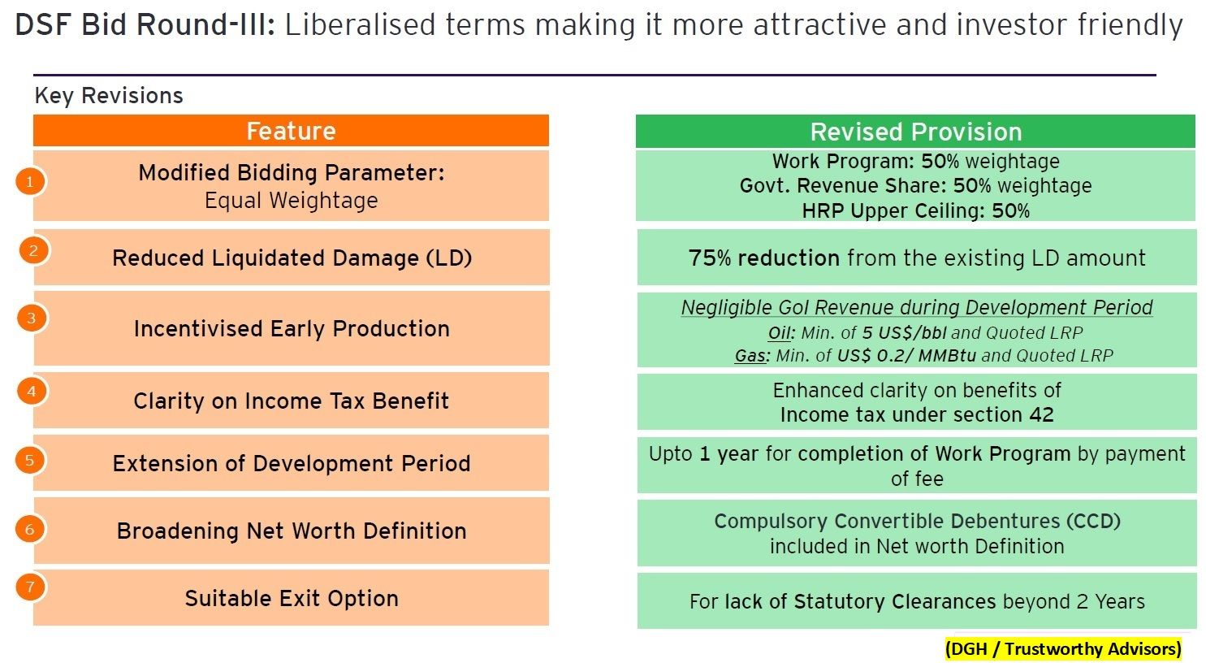

DGH extends last date for submission of bids under DSF-III to 15th March.
1. 32 Contract Areas comprising 75 Discoveries are on Offer
2. Oil and Gas already discovered in these fields by ONGC, Oil India and other oil companies.
3. These Discovered fields carry a lower risk with higher return. However, the economics will depend more on the value of the biddable parameters put in their bids by the investors and entrepreneurs.
4. In earlier bidding rounds, 30 clusters of oilfields in DSF-I and 23 clusters in DSF-II were awarded.
hashtag#oilandgas hashtag#economics hashtag#india hashtag#oilfields hashtag#dghindia hashtag#mopng hashtag#ongc hashtag#dsf

